 | DEPARTMENT OF ELECTRICAL AND ELECTRONICS ENGINEERING  MANIPAL INSTITUTE OF TECHNOLOGY  MANIPAL – 576104, KARNATAKA, INDIA  Nov 2024
Power Electronics Lab
ELE 3161
Mini Project Report
Title: -
Comparative Analysis of PWM Techniques for Electric Vehicle Powertrains

Name | Roll no. | Register No.
Harikishanthini K | 6 | 220906286
Ayush Chandra | 7 | 220906300
Shruthi Ramprasad | 8 | 220906308
Spreeha Garg | 9 | 220906310

Abstract
Electric vehicles (EVs) play a pivotal role in reducing global carbon emissions and transitioning towards sustainable energy systems. A crucial component of EVs is the inverter, which converts the direct current (DC) from the battery to alternating current (AC) for the motor. This report explores the role of Pulse Width Modulation (PWM) techniques—particularly Sinusoidal PWM (SPWM), Unipolar PWM, and Bipolar PWM—in improving the efficiency of three-phase inverters in EV powertrains. A comparative analysis highlights their impact on efficiency, harmonic distortion, and switching losses. Simulation results indicate that Unipolar PWM offers the best balance between low harmonic distortion and reduced switching losses, making it the ideal choice for EV applications.

Chapter 1: Introduction

1.1 Background & Motivation
Electric vehicles are a critical step in reducing reliance on fossil fuels and addressing environmental concerns such as climate change. The inverter is a core element of the EV powertrain, responsible for converting DC from the battery into AC to drive the motor. The efficiency of this conversion process directly affects the vehicle's performance and range, making it essential to improve inverter design and operation.
PWM techniques are commonly used to control the inverter, regulating the output voltage and current to match the motor's requirements. The right PWM technique can reduce harmonic distortion, improve motor efficiency, and minimize switching losses, all of which contribute to longer vehicle range and smoother performance.

1.2 Literature Review
The existing literature highlights several key areas where improvements in PWM techniques can optimize EV performance. The traditional SPWM method has been widely studied due to its simplicity and effectiveness, but it suffers from high Total Harmonic Distortion (THD) and significant switching losses, especially in dynamic applications like EV powertrains.
Other advanced PWM methods, including Unipolar PWM and Bipolar PWM, have been proposed to overcome these limitations. Unipolar PWM offers lower THD and reduced switching losses compared to Bipolar PWM, making it more suitable for high-efficiency applications.

1.3 Objectives
The objectives of this report are:
- To explore the various PWM techniques used in controlling inverters for EV applications.
- To analyse the performance differences between SPWM, Unipolar PWM, and Bipolar PWM.
- To recommend the most effective PWM technique for improving inverter efficiency in EV powertrains.

Chapter 2: Methodology

2.1 Introduction
In this chapter, we explore the methodologies used to compare different PWM techniques. SPWM, Unipolar PWM, and Bipolar PWM are simulated in a MATLAB/Simulink environment to assess their performance under typical EV operating conditions. The primary factors considered include harmonic distortion, switching losses, and overall efficiency.

2.2 Pulse Width Modulation Techniques
2.2.1 Sinusoidal PWM (SPWM)
SPWM is the most traditional technique used in inverter control. It generates a modulated signal by comparing a sinusoidal reference waveform with a high-frequency triangular carrier waveform. This method is simple to implement and provides smooth sinusoidal outputs, making it a common choice for three-phase inverters.
However, SPWM has limitations, including higher harmonic distortion and moderate switching losses due to fixed switching frequency and limited control over harmonics.
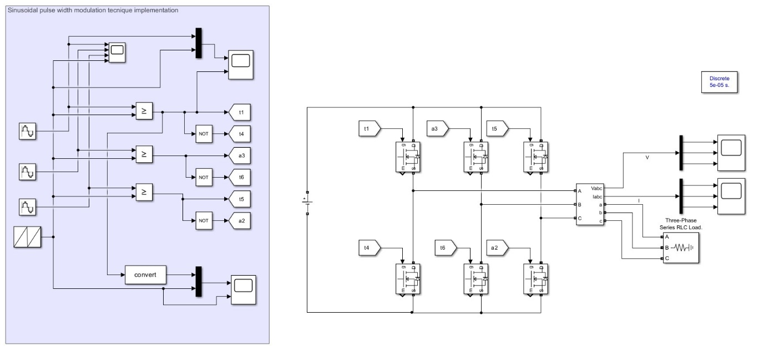
Fig 1:- SPWM Technique Implementation on Simulink

2.2.2 Unipolar PWM
Unipolar PWM improves upon SPWM by using two reference signals, one for the positive and one for the negative half-cycle of the output waveform. This technique reduces the switching losses and improves harmonic performance by switching between different voltage levels rather than toggling directly between +Vdc and -Vdc
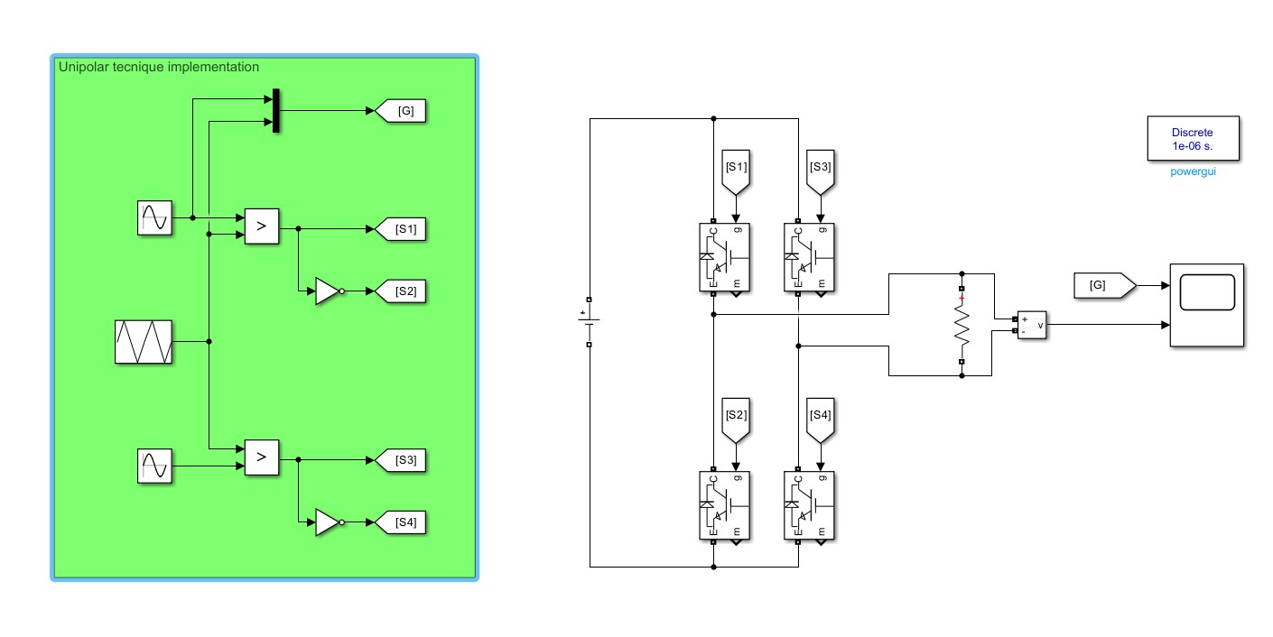
Fig 2:- Unipolar PWM Technique Implementation on Simulink

2.2.3 Bipolar PWM
Bipolar PWM is simpler than Unipolar PWM, switching the inverter output directly between +Vdc and -Vdc. While easy to implement, Bipolar PWM suffers from higher harmonic distortion and greater switching losses due to the full voltage swing.
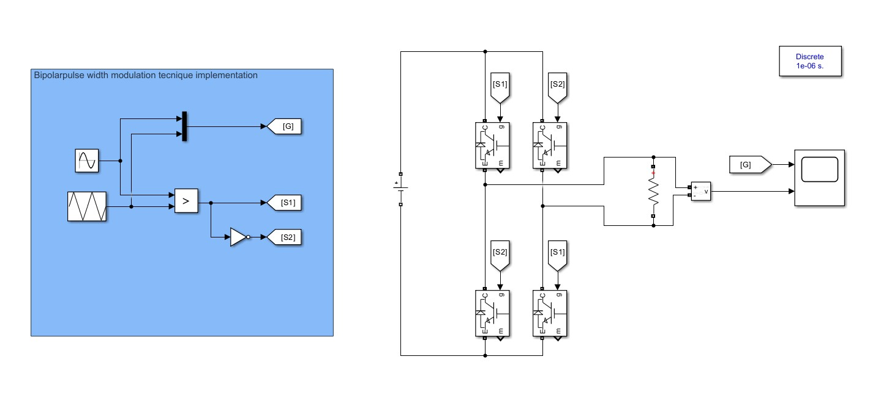
Fig 3 :- Bipolar PWM Technique Implementation on Simulink

Chapter 3: Result Analysis

3.1 Simulation Results
The simulations were conducted using MATLAB/Simulink for SPWM, Unipolar PWM, and Bipolar PWM. The following key performance indicators were analysed:
- Total Harmonic Distortion (THD): Unipolar PWM achieved the lowest THD, followed by SPWM. Bipolar PWM had the highest THD due to larger voltage swings.
- Switching Losses: Unipolar PWM exhibited significantly lower switching losses compared to Bipolar PWM. SPWM also showed moderate switching losses but was less efficient than Unipolar PWM.
- Efficiency: The overall efficiency of the inverter was highest when using Unipolar PWM, as it offered the best balance between reduced THD and lower switching losses.
The table below summarizes the simulation results:
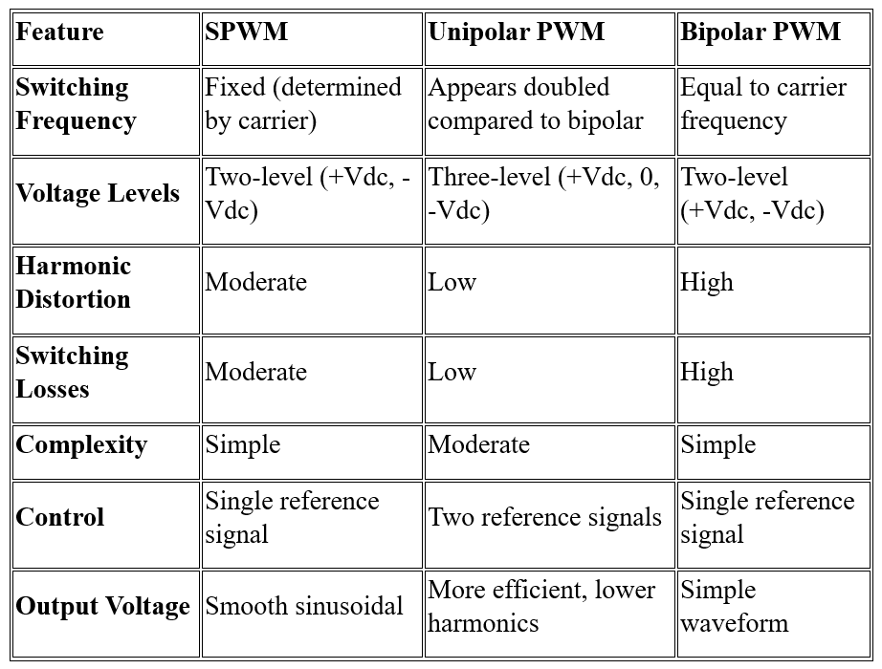
Table 1: - Coparision Table between different PWM Techniques

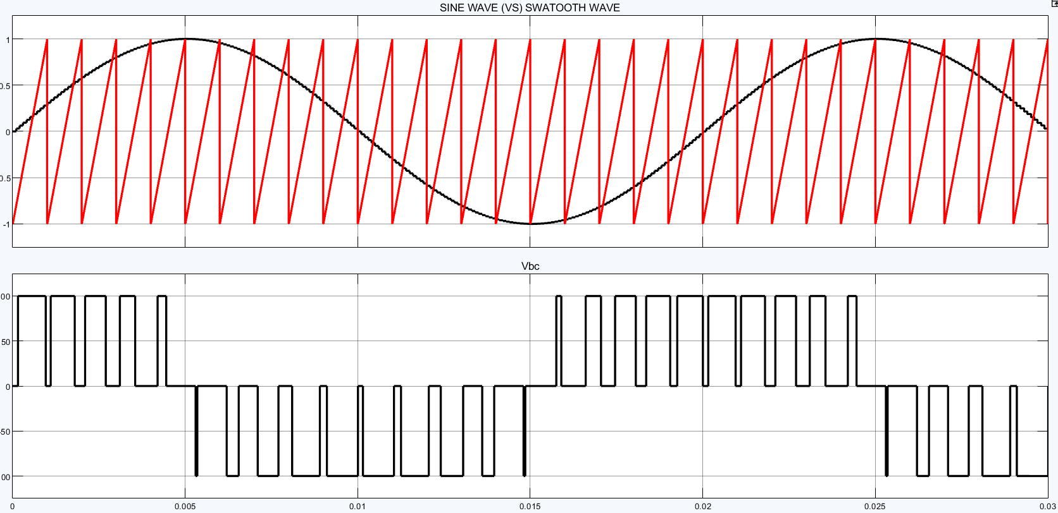
3.2 Waveform Outputs
Fig 4: - SPWM Output Waveforms

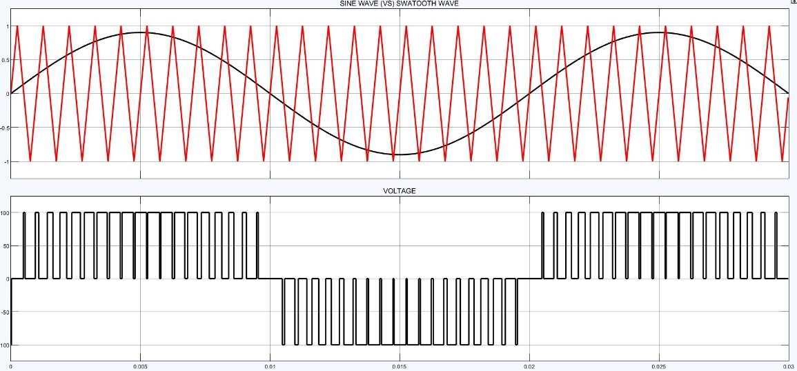
Fig 5: - Unipolar PWM Output Waveforms

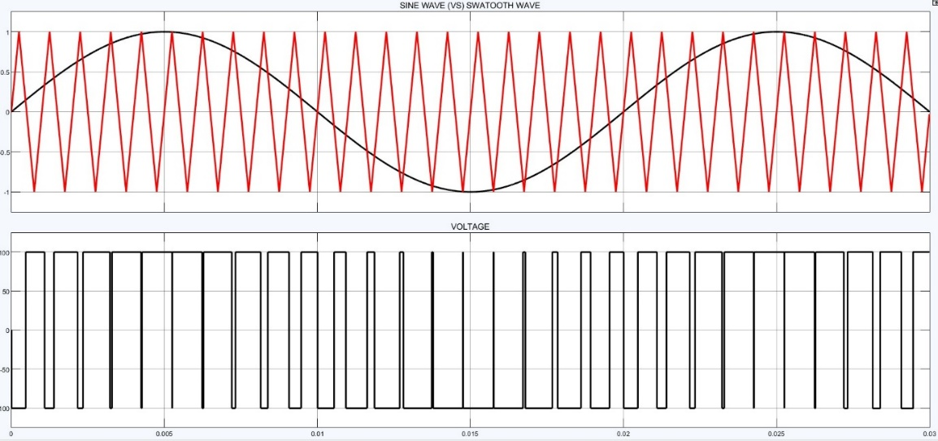
Fig 6: - Bipolar PWM Output Waveforms
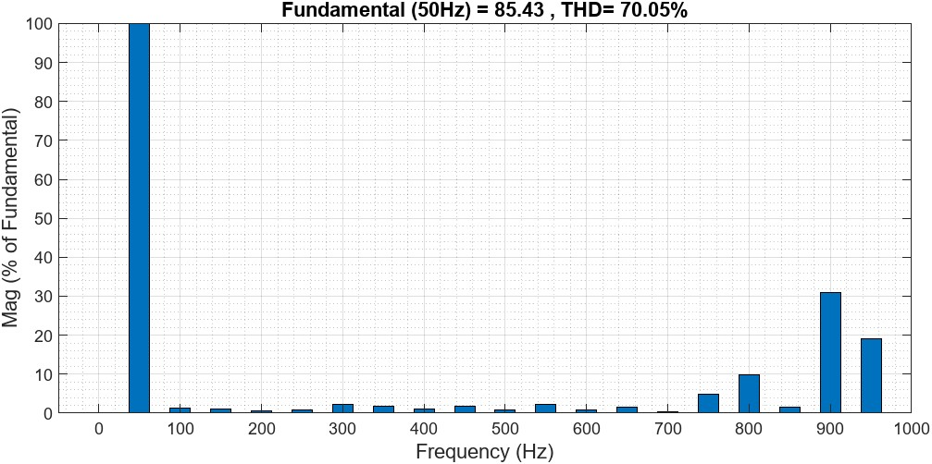
3.3 FFT analyzer Outputs
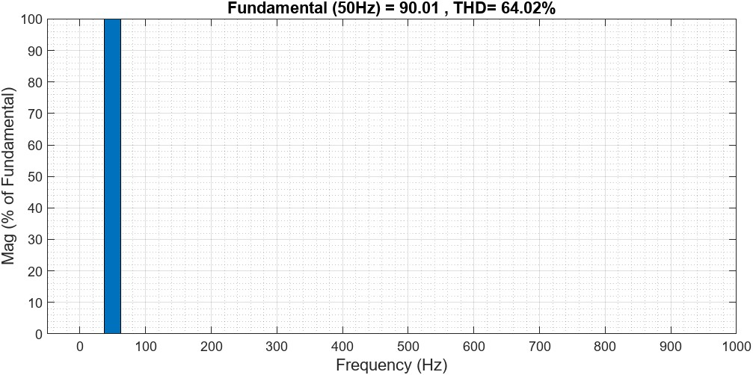
Fig74: - SPWM Output
Fig 8: - Unipolar PWM Output
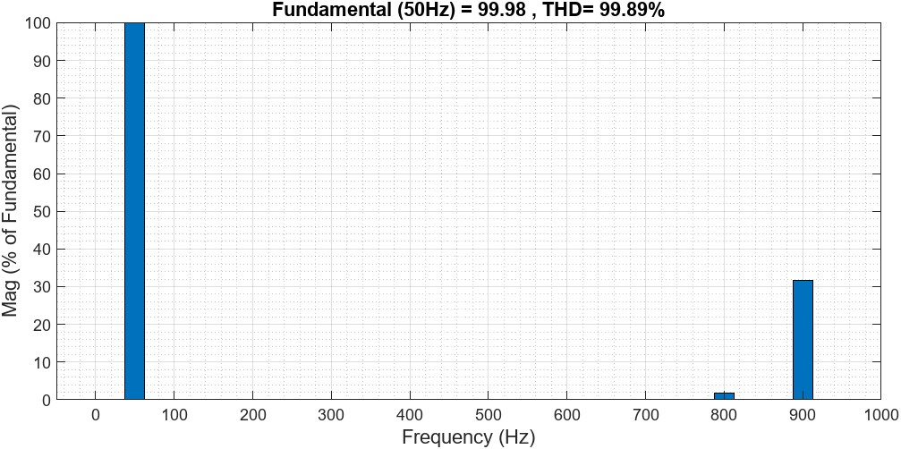
Fig 9: - Bipolar PWM Output

3.4 Discussion
The results indicate that Unipolar PWM is the most effective PWM technique for electric vehicle inverters. This conclusion is supported by the following reasons:
- Lower Harmonic Distortion (THD):
- Unipolar PWM reduces THD significantly compared to Bipolar PWM, resulting in cleaner AC waveforms. This improves motor efficiency and reduces losses caused by harmonics in the motor
- Reduced Switching Losses:
- Switching losses are lower in Unipolar PWM as it switches between +Vdc, 0, and -Vdc, rather than directly between +Vdc and -Vdc. Lower switching losses lead to better overall efficiency in EV powertrains
- Higher Inverter Efficiency:
- By reducing both THD and switching losses, Unipolar PWM achieves higher overall efficiency, which is crucial for extending the EV's driving range and improving battery life​
- Improved Motor Control:
- The effective doubling of the switching frequency in Unipolar PWM results in a smoother output waveform, allowing better control of motor speed and torque, essential for dynamic EV operation

Chapter 4: Summary and Conclusion

4.1 Conclusion
In this study, we compared the performance of three PWM techniques—SPWM, Unipolar PWM, and Bipolar PWM—under typical EV operating conditions. Based on simulation results, Unipolar PWM is the most suitable technique for EV powertrains due to its superior efficiency, lower THD, and reduced switching losses. While SPWM remains a viable option, it does not match the performance of Unipolar PWM in demanding applications. Bipolar PWM, although simpler, is less efficient and generates more harmonics.

4.2 Future Scope
Future work should explore advanced PWM techniques like Space Vector Pulse Width Modulation (SVPWM) and predictive control algorithms that may offer even better performance for EV powertrains. Implementing these techniques in hardware for real-world testing will also be an important next step.

References
- Pranay S. Shete, Rohit G. Kanojiya, Nirajkumar S. Maurya. Performance of Sinusoidal Pulse Width Modulation-based Three-Phase Inverter. International Conference on Emerging Frontiers in Technology for Rural Area (EFITRA), 2012.
- N. Mohan, T. M. Undeland, W. P. Robbins. Power Electronics: Converters, Applications, and Design. John Wiley & Sons, 1995.
- Jagan V et al. Analysis of Different PWM Techniques for Enhanced Ultrahigh Gain Z-Network Topology. International Transactions on Electrical Energy Systems, Volume 2024, https://doi.org/10.1155/2024/6645798

Individual Contribution
- Harikishanthini K (220906286): Simulation setup and analysis.
- Ayush Chandra (220906300): Research on PWM techniques.
- Shruthi Ramprasad (220906308): Report writing and data interpretation.
- Spreeha Garg (220906310): Comparative analysis and result interpretation.

Appendix: - Comparison of Different PWM Techniques

1. Sinusoidal Pulse Width Modulation (SPWM):
- Overview: In SPWM, the switching signals are generated by comparing a sinusoidal reference signal with a high-frequency triangular carrier wave. This method is commonly used in inverters to generate AC voltage.
- Operation:
  - A sinusoidal reference signal (the desired AC output) is compared with a triangular carrier wave.
  - The switching pulses are generated wherever the reference exceeds the carrier waveform.
- Characteristics:
  - Switching Frequency: Fixed (determined by the carrier frequency).
  - Output Voltage: Proportional to the amplitude of the reference signal.
  - Harmonic Content: Primarily determined by the carrier frequency and amplitude modulation index.
- Advantages:
  - Simple to implement.
  - Well-suited for applications requiring smooth sinusoidal output.
  - Easy to control amplitude and frequency.
- Disadvantages:
  - Limited control over harmonic content.
  - Lower harmonic performance compared to advanced techniques like SVPWM.

2. Unipolar PWM:
- Overview: Unipolar PWM uses two reference signals: one for the positive half-cycle and one for the negative half-cycle of the output waveform. It reduces switching losses and improves harmonic performance compared to bipolar PWM.
- Operation:
  - Two sinusoidal reference signals (one positive and one negative) are compared with a common triangular carrier wave.
  - The output switches between +Vdc, 0, and -Vdc, making the output switch between different levels rather than toggling directly between +Vdc and -Vdc as in bipolar PWM.
- Characteristics:
  - Switching Frequency: Appears to be doubled compared to Bipolar PWM because of switching between different voltage levels.
  - Output Voltage: The output is unipolar during positive and negative half-cycles.
  - Harmonic Content: Reduced harmonic distortion in the output due to lower voltage transitions.
- Advantages:
  - Reduced switching losses compared to bipolar PWM (since the output switches between +Vdc and 0 or -Vdc and 0, not between +Vdc and -Vdc directly).
  - Better harmonic performance in terms of total harmonic distortion (THD).
- Disadvantages:
  - More complex control due to the need for two reference signals.

3. Bipolar PWM:
- Overview: Bipolar PWM switches the output directly between +Vdc and -Vdc. It’s simpler to implement than unipolar PWM but results in higher switching losses.
- Operation:
  - A single sinusoidal reference signal is compared with a triangular carrier wave.
  - The inverter output switches between +Vdc and -Vdc when the reference crosses the carrier.
- Characteristics:
  - Switching Frequency: Equal to the carrier frequency.
  - Output Voltage: Switches directly between +Vdc and -Vdc.
  - Harmonic Content: Higher harmonic distortion compared to unipolar PWM due to larger voltage swings.
- Advantages:
  - Simple control with a single reference signal.
  - Easy to implement in both hardware and simulation.
- Disadvantages:
  - Higher switching losses due to full voltage swing between +Vdc and -Vdc.
  - Higher harmonic content compared to unipolar PWM.

